MFE-II Report

**STUDENT PERSPECTIVE ON AI**

Prepared in the partial fulfilment for the course of

“**MTH1711-Mathematics for Engineers-II**”

Submitted To:

**Dr. Ranjib Banerjee**

Submitted by:

Shradha Aggarwal (220465)

Nishtha Jain (220460)

Utkarsh Tonk (220453)

Guneet Chawla (220415)

**School of Engineering & Technology**

##### BML MUNJAL UNIVERSITY, GURUGRAM

**(May 14, 2023)**

**ACKNOWLEDGEMENT**

Dr. Ranjib Banerjee, our mentor, has our sincere gratitude for her important guidance and help in getting our project finished. He helped us at every turn, and it was his direction that we were able to complete the assignment successfully. We want to express our gratitude to other support staff members who helped us by providing the data and information that was crucial and necessary and without which we would not have been able to complete this report effectively.

We also like to express our gratitude to BML Munjal University for accepting our proposal in our area of competence. Additionally, we would like to thank our fellow mates for their assistance and inspiration as we worked on this assignment.

**Introduction**

The science of artificial intelligence (AI), which is expanding quickly, is altering how we interact with technology. Virtual assistants, self-driving cars, medical diagnosis software, and financial analysis software are just a few examples of how AI has been interwoven into numerous facets of our daily life. Thanks to developments in AI, machines can now carry out complicated jobs that formerly required human intelligence.

For students, future professions and the development of society, knowledge of AI is becoming more and more crucial. Students want to be ready for these changes because they understand that AI has the ability to revolutionize sectors and open up new opportunities. Overall, students are interested in learning more about this fast-developing topic and are aware of the value of understanding AI in today’s tech world.

**Abstract**

In this report, we'll examine AI from a student's point of view. Students have a distinct viewpoint on AI and its possible effects on society because they are the next generation of innovators. We'll examine how students are exposed to AI and the difficulties they encounter when trying to comprehend and make use of this technology. The study will start off by giving a data where the students rate their knowledge on AI and their perspective on different parameters like dehumanization, job replacement, economic crisis and rate the utility of AI in education. Also, whether the GPA is affected based on their AI knowledge ratings. The dependency of these factors based on their AI knowledge is being analyzed further in the report. The study will also include instances of how AI is applied in learning and teaching processes. The analysis is supported by various pie charts.

**Methodology**

This dataset comprises the findings of a survey that was done in March 2023 among 90 undergraduate students. The poll was distributed through social media groups and carried out online. The survey's objective was to learn more about how students view artificial intelligence's place in the classroom. The information was gathered from an online resource. The data obtained was analyzed using R on the dataset available at Kaggle website

<http://www.kaggle.com>

**Dataset:**

[mfe data 14.05.23.xlsx](https://1drv.ms/x/s!Aghu57-FI49BhjS-c-p-V5fOLE__?e=1vkdXM)

**Survey**

Questions are numbered according the dataset.

Question 1: On a scale of 1 to 10, how informed do you think you are about the concept of artificial intelligence? (1-not informed at all, 10-extremely informed) {Q1.AI_knowledge}

Question 2: Express your agreement or disagreement with the following statement, “AI encourages dehumanization”: (Strongly Disagree (1), Partially Disagree (2), Neutral (3), Partially Agree (4), Fully Agree (5)) {Q3#1.AI_dehumanization}

Question 3: Express your agreement or disagreement with "AI will lead to Job Replacement": (Strongly Disagree (1), Partially Disagree (2), Neutral (3), Partially Agree (4), Fully (5). {Q3#2.Job_replacement}

Question 4: Express your agreement or disagreement with "AI will lead to a global economic crisis": (Strongly Disagree (1), Partially Disagree (2), Neutral (3), Partially Agree (4), Fully (5). {Q4#2.Economic_crisis}

Question 5: On a scale of 1 to 10, how useful do you think AI would be in the educational process? (1- not useful at all, 10-extremely useful) {Q7.Utility_grade}

Question 6: What is your GPA for your last year of study? { Q16.GPA}

Question 7: What do you think is the main advantage that AI would have in the learning process? {Q9.Advantage_learning}

o Personalized lessons according to students' needs

o Universal access for all students eager to learn, including those with special needs

o More interactive and engaging lessons for students

Question 8: What do you think is the main advantage that AI would have in the teaching process? {Q8.Advantage_teaching}

o Teachers can be assisted by a virtual assistant for teaching lessons and answering students' questions immediately

o More efficient management of teachers' time

o More interactive and engaging lessons for students

Question 9: What do you think is the main disadvantage that AI would have in the educational process? { Q11.Disadvantage_educational_process}

o Lack of a relationship between students and teacher

o Internet addiction

o rarer interactions between students and teachers

o Loss of information caused by possible system failure

**Analysis and results:**

Both descriptive, testing, and statistical data analyzing were done using RStudio.

The 91 students were divided into three major categories on the basis of their AI knowledge out of 10 (less, average, high).

* less knowledge people rated their AI knowledge either 1, 2 or 3. They were found to be 9 in number.
* Average knowledge people rated their AI knowledge either 4,5,6 or 7. They were found to be 62 in number.
* High knowledge people rated their AI knowledge either 8,9 or 10. They were found to be 20 in number.

1. Is there a statistically significant relationship between an individual's level of AI knowledge and their level of agreement with the statement 'AI encourages dehumanization'?

**1.1Data Analysis**: Students were further divided on the basis of their perception if they agree AI will lead to dehumanization or not. To answer this question, we performed a chi-squared test of independency. The null hypothesis is that there is no significant relationship between AI knowledge and agreement with the statement, and the alternative hypothesis is that there is a significant relationship. We first created a likelihood table with AI knowledge as one of the variables and made a pact with the statement as the other.

* + 1. **A pie chart**

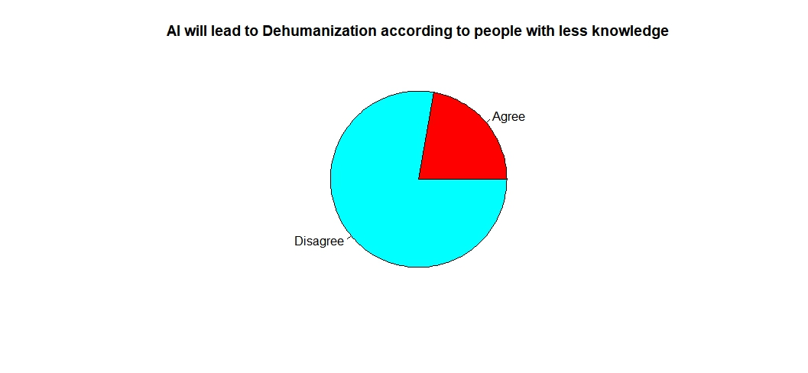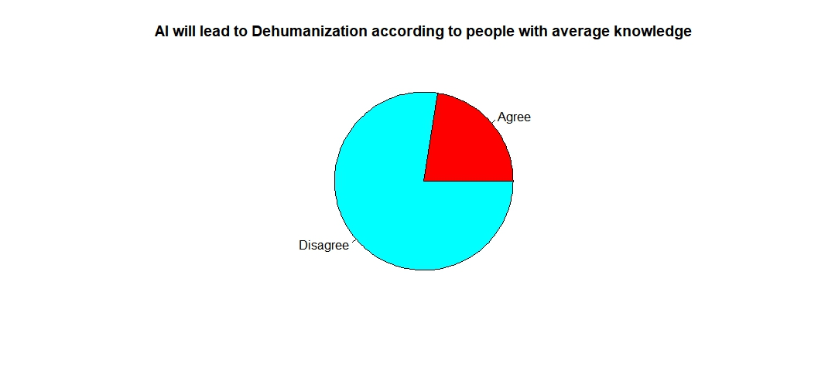

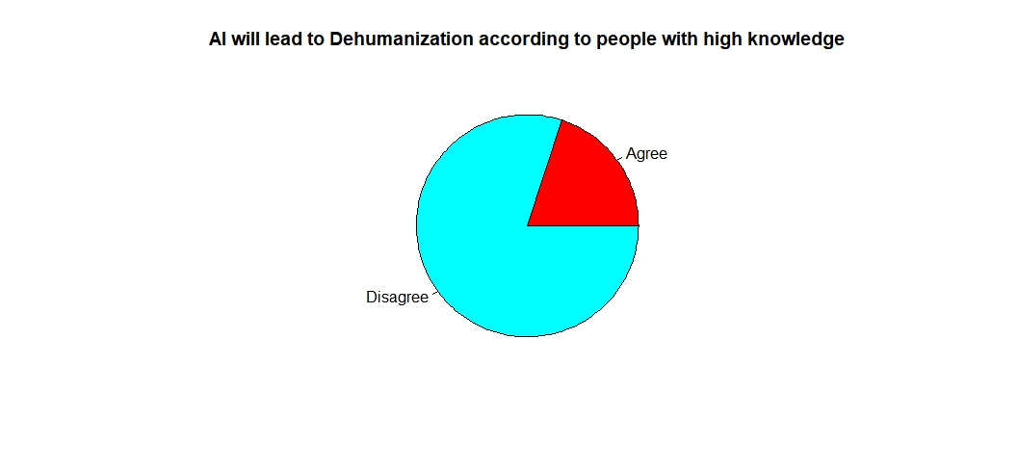

Pie charts were made on basis of three groups of people. There was not much difference in proportion of people who agreed and disagreed with the statement. And we could make out from the pie chart that there was no such dependency of opinions on their knowledge in this field. Almost 20-25% od people from each group agreed with the statement.

**1.2. Test analysis:** The chi squared value was found to be 0.059 and the critical value was 5.991 when the confidence level was 95% and degree of freedom 2. It can be seen that the chi squared value is less than the critical value.

**1.3Statistical Summary (using RStudio)**

Contingency table:

|  |  |  |  |
| --- | --- | --- | --- |
|  | Less knowledge | Average knowledge | High knowledge |
| Will lead to dehumanization | 2 | 14 | 4 |
| Will not lead to Dehumanization | 7 | 48 | 16 |

Summary:

|  |  |  |  |  |
| --- | --- | --- | --- | --- |
| P-value | Degree of Freedom | Alpha | Critical Value | X-squared |
| 0.9709 | 2 | 0.05 | 5.991 | 0.059 |

**1.4 Result:** We fail to reject null hypothesis. Hence, there is no significant relationship or dependency on both the parameters their knowledge in AI is independent of their perceptions if AI will lead to Dehumanization or not. The above result has been proven from graphs as well as statistical data analysis.

1. Is there a statistically significant relationship between someone's level of AI understanding and their level of agreement with the statement that "AI causes job replacement"?
   1. **Data analysis:** Students were further divided on the basis of their perception if they agree AI will replace humans in job sector or not. To find the significant relationship between AI knowledge and job replacement, chi- squared test of independence is being performed. The alternative hypothesis is that there is a meaningful connection between agreement with the statement and AI knowledge, contrary to the null hypothesis that there is no meaningful connection.

**2.1,1 pie chart:**

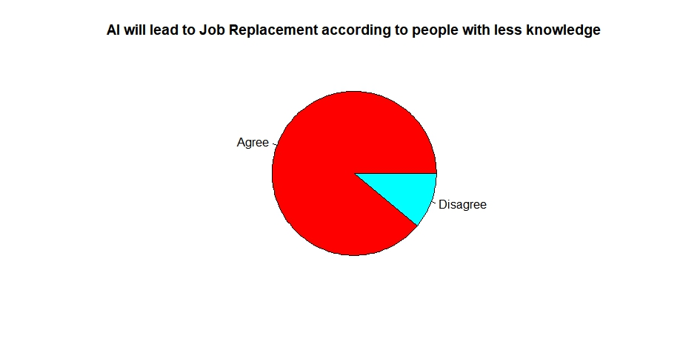

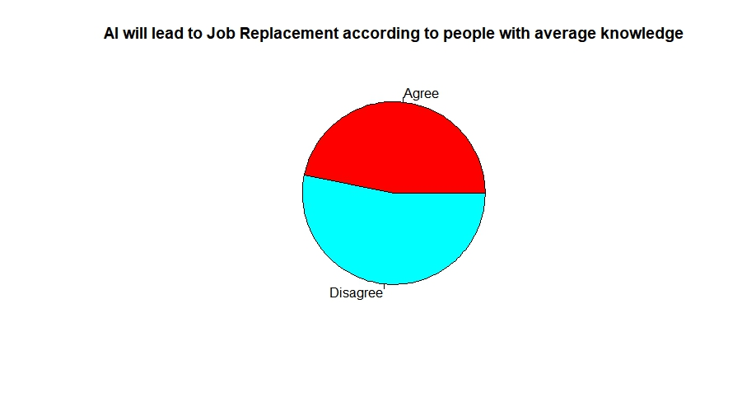

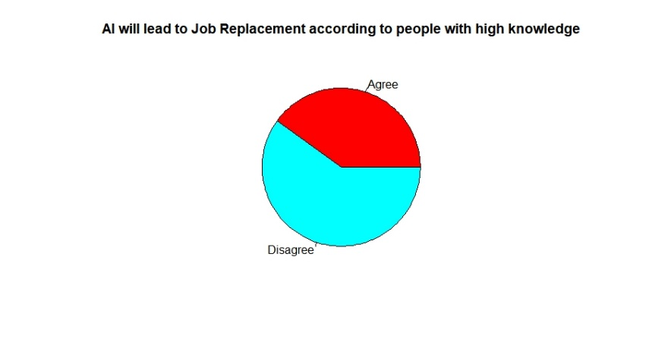

As we can see from the pie charts, people with least knowledge of AI has more (>75%) proportion of agreement than people with average knowledge (40%-50%). People with average knowledge has more proportion of agreement than people with high knowledge (30%-35%) of AI. We can observe level of disagreement increases with increase in knowledge of AI among people. Hence, we can see a noticeable relationship between agreement with the statement, “AI will replace human jobs” and level of AI knowledge.

* 1. **Test analysis:** A contingency table was made with one variable having the level of knowledge among students and the agreement and disagreement with job replacement. The chi- squared value was found to be 6.4923 and the critical value was 5.991 keeping the alpha 0.05 and degree of freedom 2. From this data, it is observable that chi-squared value is more than critical value.
  2. **Statistical summary (using RStudio):**

Contingency table

|  |  |  |  |
| --- | --- | --- | --- |
|  | Low knowledge | Average knowledge | High knowledge |
| Will lead to job replacement | 8 | 29 | 8 |
| Will not lead to job replacement | 1 | 33 | 12 |

Summary:

|  |  |  |  |  |
| --- | --- | --- | --- | --- |
| P-value | Degree of freedom | Alpha | Critical Value | X-squared |
| 0.03892 | 2 | 0.05 | 5.991 | 6.4923 |

* 1. **Result:** From this statistical summary, it is concluded that that null hypothesis is rejected as chi-squared value is more than the critical value. Which implies that the knowledge of AI is dependent on the perceptions on if AI will lead to job replacement or not. The result has been proven from both data analysis, visual analysis and statistical analysis that level of knowledge in AI has significant impact on perception of students in job replacement sector.

1. Does one's amount of understanding about AI and their level of agreement with the claim that "AI causes economic crisis" are related statistically?
   1. **Data Analysis:** Each group of people which were previously divided on the level of their AI knowledge were further divided on agreement or disagreement with the statement, ”AI will lead to economic crisis”. We used a chi-squared test of independence to get the answer to this query. The alternative hypothesis is that there is a substantial association, whereas the null hypothesis is that there is no significant relationship between two factors.
      1. **Pie chart**

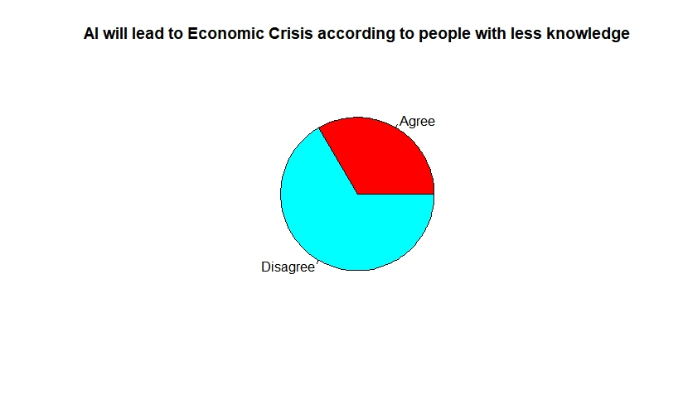

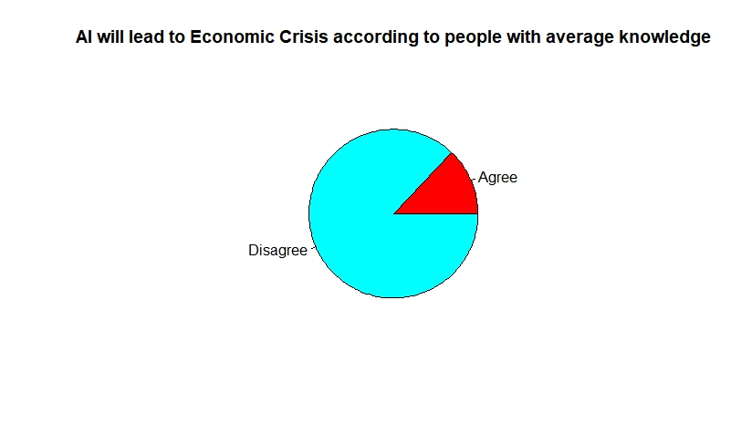 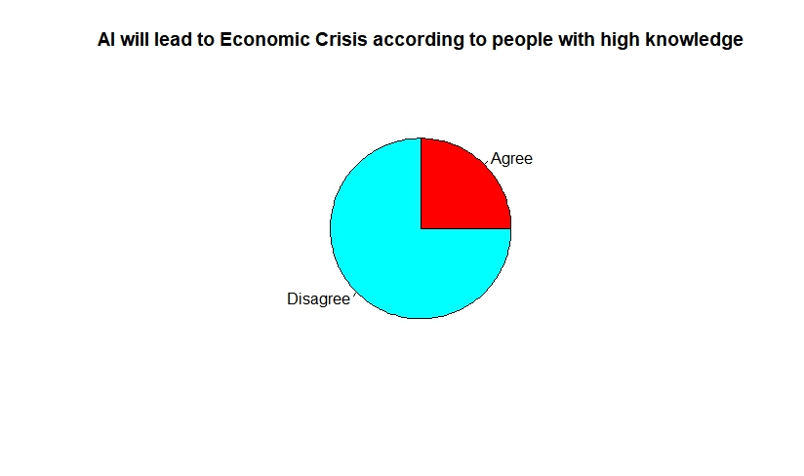

Proportion of people who agree that AI will lead to economic crisis is least in people with average AI knowledge (approx. 15%) while maximum proportion of people agreeing with the statement are people with less AI knowledge (more than 35%) while almost (approx. 24%) people with high knowledge of AI agree with the statement. We could not see any specific trend or relationship between agreement with the statement and their AI knowledge.

* 1. **Test Analysis:**  A contingency table was made with one variable having the level of knowledge among students and the agreement and disagreement with pact of the statement whether or not AI will lead to economic crisis. When the confidence level was 95% and the degree of freedom 2 was used, the chi-squared value was found to be 3.327 and the critical value was 5.991. It can be clearly seen that the chi-squared value is less than the critical value.
  2. **Statistical Summary (using RStudio):**

Contingency table:

|  |  |  |  |
| --- | --- | --- | --- |
|  | Less knowledge | Average knowledge | High knowledge |
| Will lead to economic crisis | 3 | 8 | 5 |
| Will not lead to economic crisis | 6 | 54 | 15 |

Summary table:

|  |  |  |  |  |
| --- | --- | --- | --- | --- |
| P-value | Degree of Freedom | Alpha | Critical Value | X-squared |
| 0.1982 | 2 | 0.05 | 5.991 | 3.237 |

* 1. **Result:** We failed to reject null hypothesis. Since their knowledge of AI is unrelated to their opinions on whether or not AI will cause an economic crisis, there is no substantial relationship between or dependency on both characteristics. It was already proved from pie charts that there was no trend and the same was seen when we performed hypothesis testing on data. Both the variables are independent of each other.

1. Is there a statistical relationship between someone's level of comprehension about AI and the rate of utility of AI in education according them?
   1. **Data analysis:** The already grouped people were subdivided into three more categories according to their ratings of utility of AI in education purposes. The subgroups were based on their ratings (less utility, average utility, high utility). We performed a chi-squared test of independency to check if their level of Ai knowledge is dependent on their rating of utility. The null hypothesis is that there is no significant relationship between two taken factors, and the alternative hypothesis is that there is a significant relationship.
      1. **Pie chart**

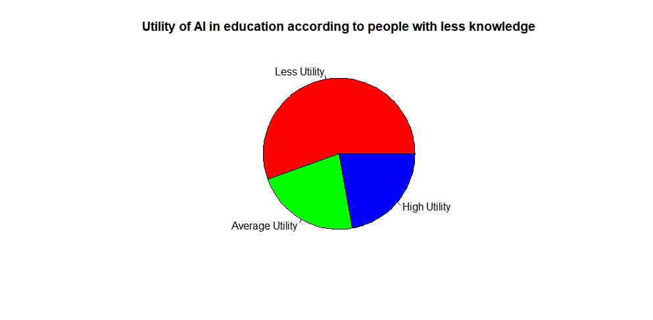

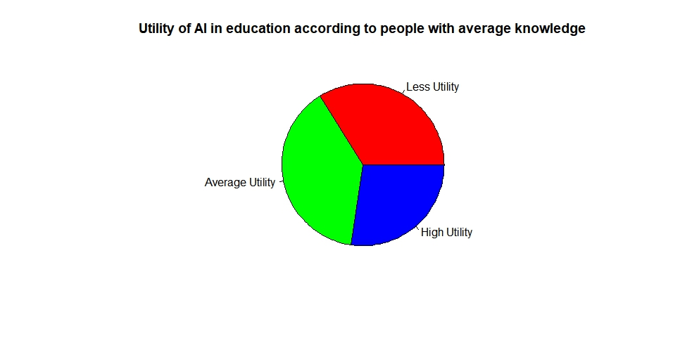

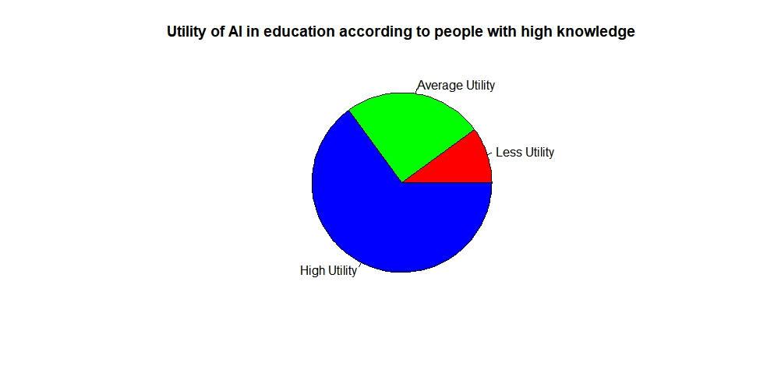

On the basis of above pie charts, several conclusions could be made. More than 50% of people belonging to less knowledgeable category thinks there is very less utility of AI in education purposes. While 20% among them thinks there is average and high utility respectively.

35% of people having average knowledge believes there is less and average utility of AI in educational field and 30% people of same group thinks there is high utility.

Almost 65% of people with high knowledge of AI believes there is high utility of AI in education which is highest proportion of all the three groups. And 25% of people belonging to same category believes in average utility. Only 10% thinks there is less utility which is least among all the three groups.

Proportion of people who gave least rating to utility decreased with increase in AI knowledge. Hence, we can conclude ratings given to AI by different groups of people depends on their knowledge in AI.

* 1. **Test analysis:**  A contingency table was made with one variable having the level of knowledge among students and the other variable was ratings given to AI based on its utility in education. When the alpha is 0.05 and the degree of freedom is 4, the chi-squared value and critical value was found to be 25.07 and 9.488 respectively.
  2. **Statistical summary (using RStudio)**

Contingency table:

|  |  |  |  |
| --- | --- | --- | --- |
|  | Less knowledge | Average knowledge | High knowledge |
| Less utility | 5 | 21 | 2 |
| Average utility | 2 | 24 | 5 |
| High utility | 2 | 5 | 13 |

Summary:

|  |  |  |  |  |
| --- | --- | --- | --- | --- |
| P-value | Degree of freedom | Alpha | Critical Value | X-squared |
| 0.00004875 | 4 | 0.05 | 9.488 | 25.07 |

* 1. **Result:** From the above analysis, the result can be concluded that the null hypothesis is rejected. So, it means knowledge of AI is related and dependent on their ratings of utility. The result we concluded from pie chart is supported mathematically and statistically when we performed hypothesis testing on data provided by students.

1. Is there a statistically significant relationship between someone's level of AI understanding and the GPA of their last year of study?
   1. **Data analysis:** Students were divided again into two groups where the score of 5.0-7.5 GPA was said to be low grade and 7.5-10.0 GPA was categorized as high grade. For the data analysis of this statistics, we used chi- squared test of independence to check whether there is null hypothesis or alternate hypothesis. Where null hypothesis states GPA is independent of student’s AI knowledge, in contrary to alternate hypothesis.
      1. **pie chart**

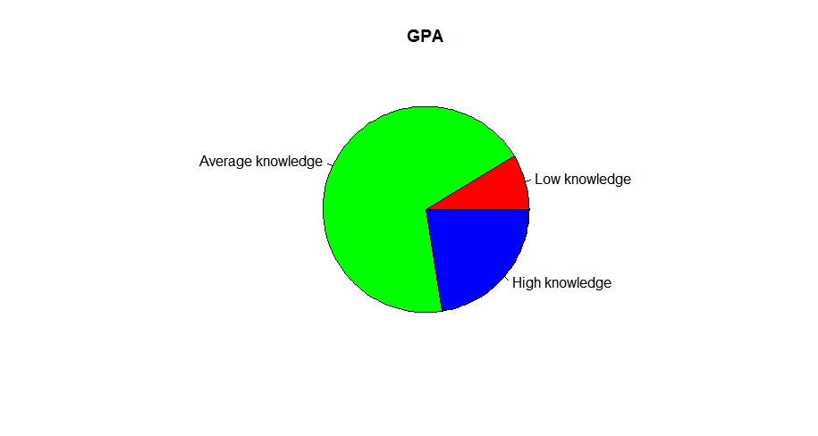

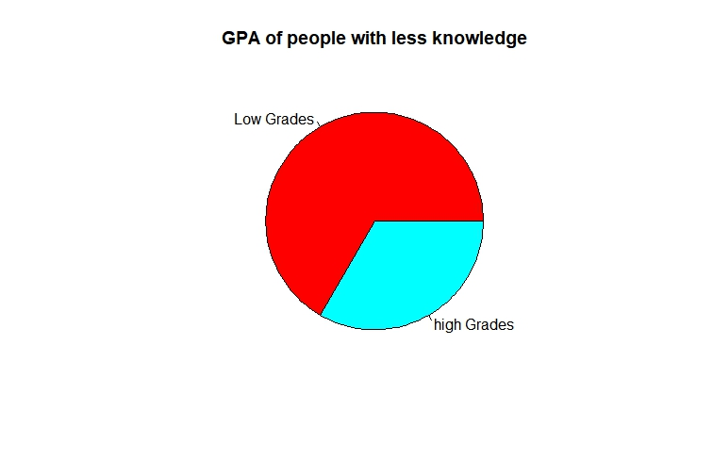

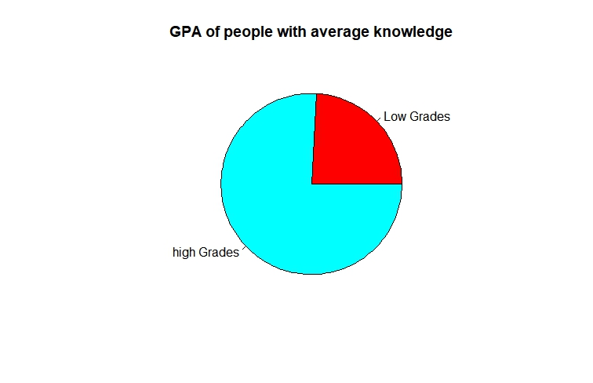

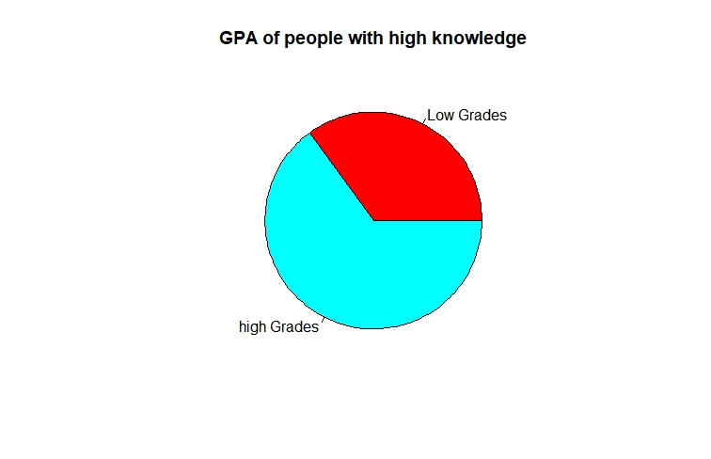

Almost 65% of people belonging to low knowledgeable category scored low grade which is highest among all three categories. While only 30% of people having high knowledge of AI scored low grades. We could make out that high knowledgeable people had high proportion in scoring high grades which is contrary to less knowledgeable people.

* 1. **Test Analysis:** A contingency table was made with one variable having the level of knowledge among students and the other variable was GPA in the last year of study. The chi- squared value was found to be 6.871 and critical value 5.991 when the alpha is 0.05 and degree of freedom 2. This shows that the chi-squared value is more than the critical value.
  2. **Statistical summary (using RStudio):**

Contingency table-

|  |  |  |  |
| --- | --- | --- | --- |
|  | Less knowledge | Average knowledge | High knowledge |
| Low grades | 6 | 15 | 7 |
| High grades | 3 | 47 | 13 |

Summary:

|  |  |  |  |  |
| --- | --- | --- | --- | --- |
| P-value | Degree of Freedom | Alpha | Critical Value | X-squared |
| 0.0322 | 2 | 0.05 | 5.991 | 6.871 |

* 1. **Result:** From this test and analysis and statistical summary, it is concluded that the null hypothesis is rejected which means that knowledge of AI is dependent on the GPA of the last year of study. Null hypothesis is rejected. The same result came out of both visual analysis which was using pie charts and statistical analysis which was performed mathematically using RStudio.

1. What do you think is the main advantage that AI would have in the learning process?
   1. **Pie chart**

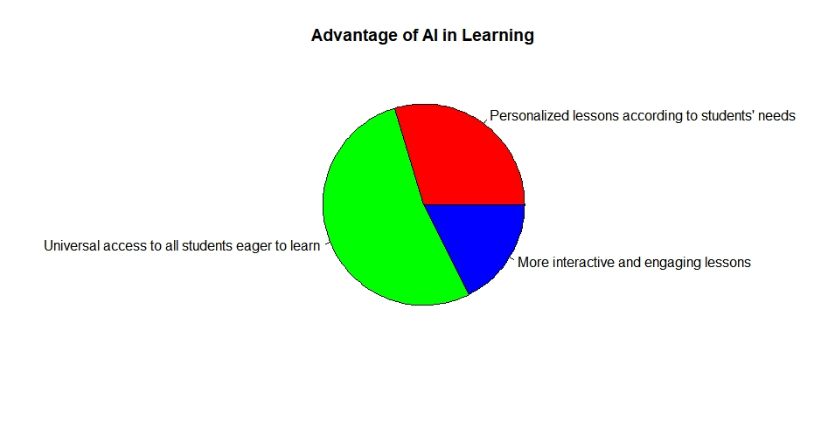

More than 50% of people thinks that the main advantage of AI is that it will give universal access to all students who are eager to learn. While 30% believes that it will provide with more personalized lessons according to student’s needs. And the remaining thinks that it will have more interactive and engaging lessons in the education field.

1. What do you think is the main advantage that AI would have in the teaching process?
   1. **Pie chart:**

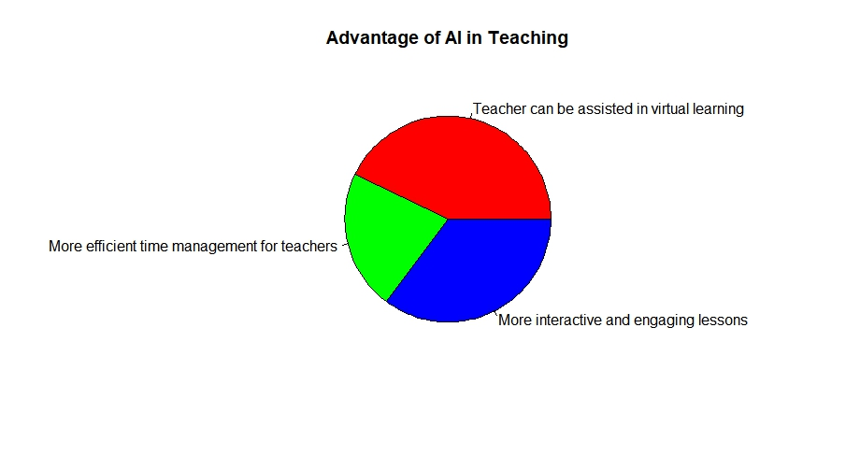

Approximately 40% of people believes that teacher can be assisted in virtual learning and other 40% thinks that it will have more interactive and engaging lessons. The remaining 20% have a thought that it will help in more efficient time management for teachers.

1. What do you think is the main disadvantage that AI would have in the educational process?
   1. **Pie chart:**

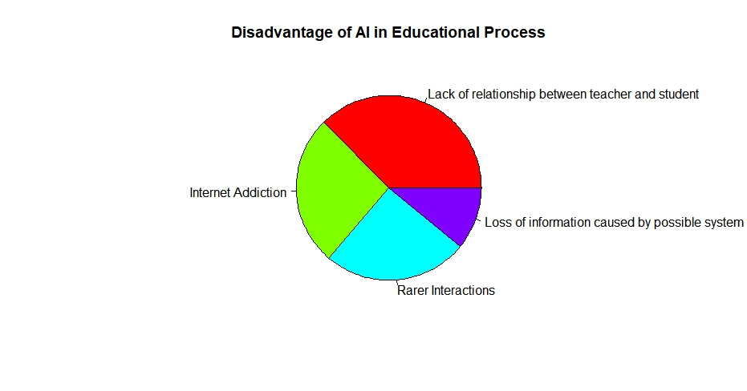

According to this pie chart, approx. 42% of people thinks that because of AI there will be lack of relationship between teacher and student. 25% of the remaining believes there will be emergence of internet addiction and other 25% believes there will be rarer interactions. The remaining 8% thinks that because of AI there will be possibility of loss of information caused by possible system.

**Conclusion**

From all the above analysis which includes test analysis, statistical analysis and data analysis it can be said that the perception of students on the factors like GPA, rate of utility and replacements in jobs are dependent on one’s knowledge in AI. Whereas factors like dehumanization and economic crisis are independent of one’s knowledge in AI. We also get to know about people’s perceptions of AI in the field of learning and teaching and how it is helpful in the educational field is also being shown in the above analysis. Also, we get to know about various opinions about the disadvantages of AI based upon the perceptions of student.

**Reference links:**

* <https://www.kaggle.com/datasets/gianinamariapetrascu/survey-on-students-perceptions-of-ai-in-education>
* <https://classroom.google.com/c/NTEyMDUzMzQyOTI3>
* <https://classroom.google.com/c/NTEyMDUzMzQyOTI3/a/NTk3ODExMzk5MTkw/details>